PLANT SYSTEMATICS

INTRODUCTION:
- Systematics (Lt. systema, organised whole) is the scientific study of the diversity of organisms, and any relationships between them.
- The idea coincides with taxonomy (Gr. taxis, arrangement; nomos, rule), which deals with the study of classification, including its principles, rules and procedures. Thus, plant systematics deals with the classification of the organisms recognised as plants.

In 1969, American biologist Robert H. Whittaker established a five-kingdom system recognising Monera, Protista, Fungi, Plantae and Animalia as distinct kingdoms.

- Plant systematics is a science that includes and encompasses traditional taxonomy; however, its primary goal is to reconstruct the evolutionary history of plant life.
- It divides plants into taxonomic groups, using morphological, anatomical, embryological, chromosomal and chemical data.

Criteria for Classification

- Members of the Kingdom Plantae are eukaryotic, multicellular, and mostly autotrophs that can perform photosynthesis.

- The plants are classified into various subgroups on the basis of-

- Presence or absence of flowers
- Presence of a differentiated plant body
- Presence of seeds
- Presence of a well-defined vascular system

Classification of Plants

On the basis of the mode of reproduction (seedless vs seed-bearing plants), the classification scheme of Kingdom Plantae is summarised as follows:

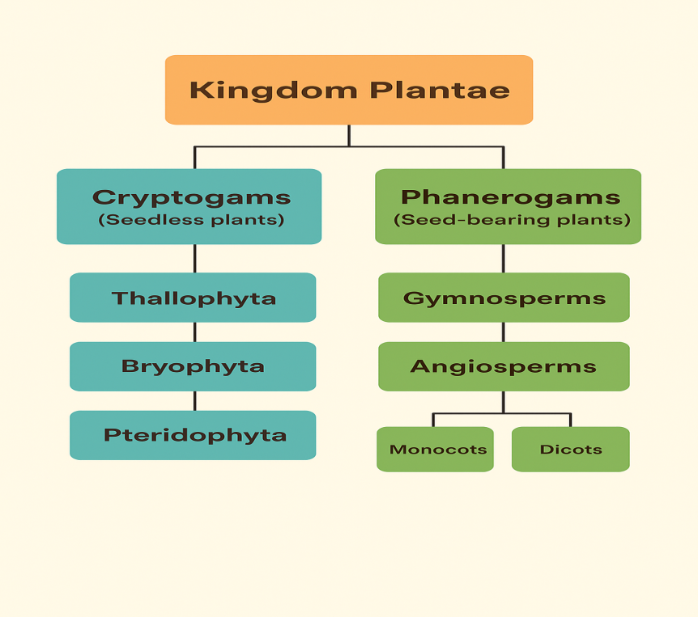

1. Cryptogams (Gr. kryptos, hidden; gamos, marriage)
Cryptogams are simple-structured organisms that do not make seeds and reproduce with the help of spores. Most of these plants or plant-like organisms lack a well-developed vascular system and a well-differentiated body with roots, stems or leaves.

A.1. Thallophyta (Gr. thallos, young undifferentiated shoot; phyta, plant)
- Organisms with a thallus-shaped (undifferentiated), primitive and simple body.
- Thallus may be branched or unbranched and colonial or filamentous in structure.
- Lacks a well-developed vascular system.
- Mostly autotrophic and can be found in moist places.
Example: Volvox, Spirogyra, Red algae, etc.

A.2. Bryophyta (Gr. bryon, moss; phyta, plant)
- Organisms possess root-like, stem-like and leaf-like structures, but the body is still not properly differentiated.
- Grow in the moist terrestrial region, but require water for reproduction.
- Lacks a well-developed vascular system.
Example: Mosses, Liverworts, Hornworts, etc.

A.3. Pteridophyta (Gr. pteris, fern; phyta, plant)
- Organisms with a well-differentiated body, divided into roots, stems and leaves- visible in the dominant sporophyte phase.
- Large leaves called fronds are pinnately compound.
- Possess a vascular system that helps in the conduction of water and minerals.
Example: Pteris, Adiantum, etc.

2. Phanerogams (Gr. phaneros, visible; gamos, marriage)
Phanerogams are considered higher plants that produce seeds for reproduction. Their body is well-developed with a highly developed vascular system and can be differentiated into roots, stems and leaves.

B.1. Gymnosperm (Gr. gymnos, naked; sperma, seed)
- These plants possess a highly developed body that can be properly differentiated into roots, stems and leaves.
- Well-developed tap root system present
- Well-developed vascular system present.
- Microsporophylls and megasporophylls aggregate to form male and female cones, respectively.
- Fruits do not enclose seeds.
- Do not possess flowers.
Example: Pinus, Cycas, etc.

B.2. Angiosperm (Gr. angeion, vessel; sperma, seed)
- Plants characterised by flowers with double fertilisation
- Fruits enclose the seeds.
- Well-developed vascular system.

B.2.a. Monocot (Gr. monos, one; kotyledon, cup-shaped hollow)
Single cotyledon in the embryo.
Presence of an adventitious root; the tap root is temporary.
Cambium absent.
Parallel venation in leaves.
Example: Zea mays, Oryza sativa, etc.

B.2.b Dicot (Gr. di, two; kotyledon, cup-shaped hollow)
- Two cotyledons in the embryo.
- Presence of tap root.
- Cambium is arranged in a ring.
- Reticulate venation in leaves.
Example: Cicer arietinum, Mangifera indica, etc.

